**DEPARTMENT OF ELECTRONICS AND COMMUNICATION ENGINEERING**

Branch: ECE Subject : Analog Electronic

Year : II Subject code : 1151EC103

Sem : III Faculty : Dr.S.SHIYAMALA

1. **Define current steering.**

In integrated circuit design biasing circuits use constant-current sources. Here, the constant d.c. Current called reference current is generated at one location and is then **replicated** at various other location for biasing the various stages of amplifier present in the circuit. This process is known as **current steering**.

1. **State the advantage of current steering.**

**Advantage of current steering process**

* The external component such as precision resistors required to generate a predictable and stable reference current, need not be repeated for every amplifier stage.
* The bias current of the various stages track each other when there is any change due to power-supply voltage or temperature.

1. **Draw the basic constant current source circuit using MOSFET**

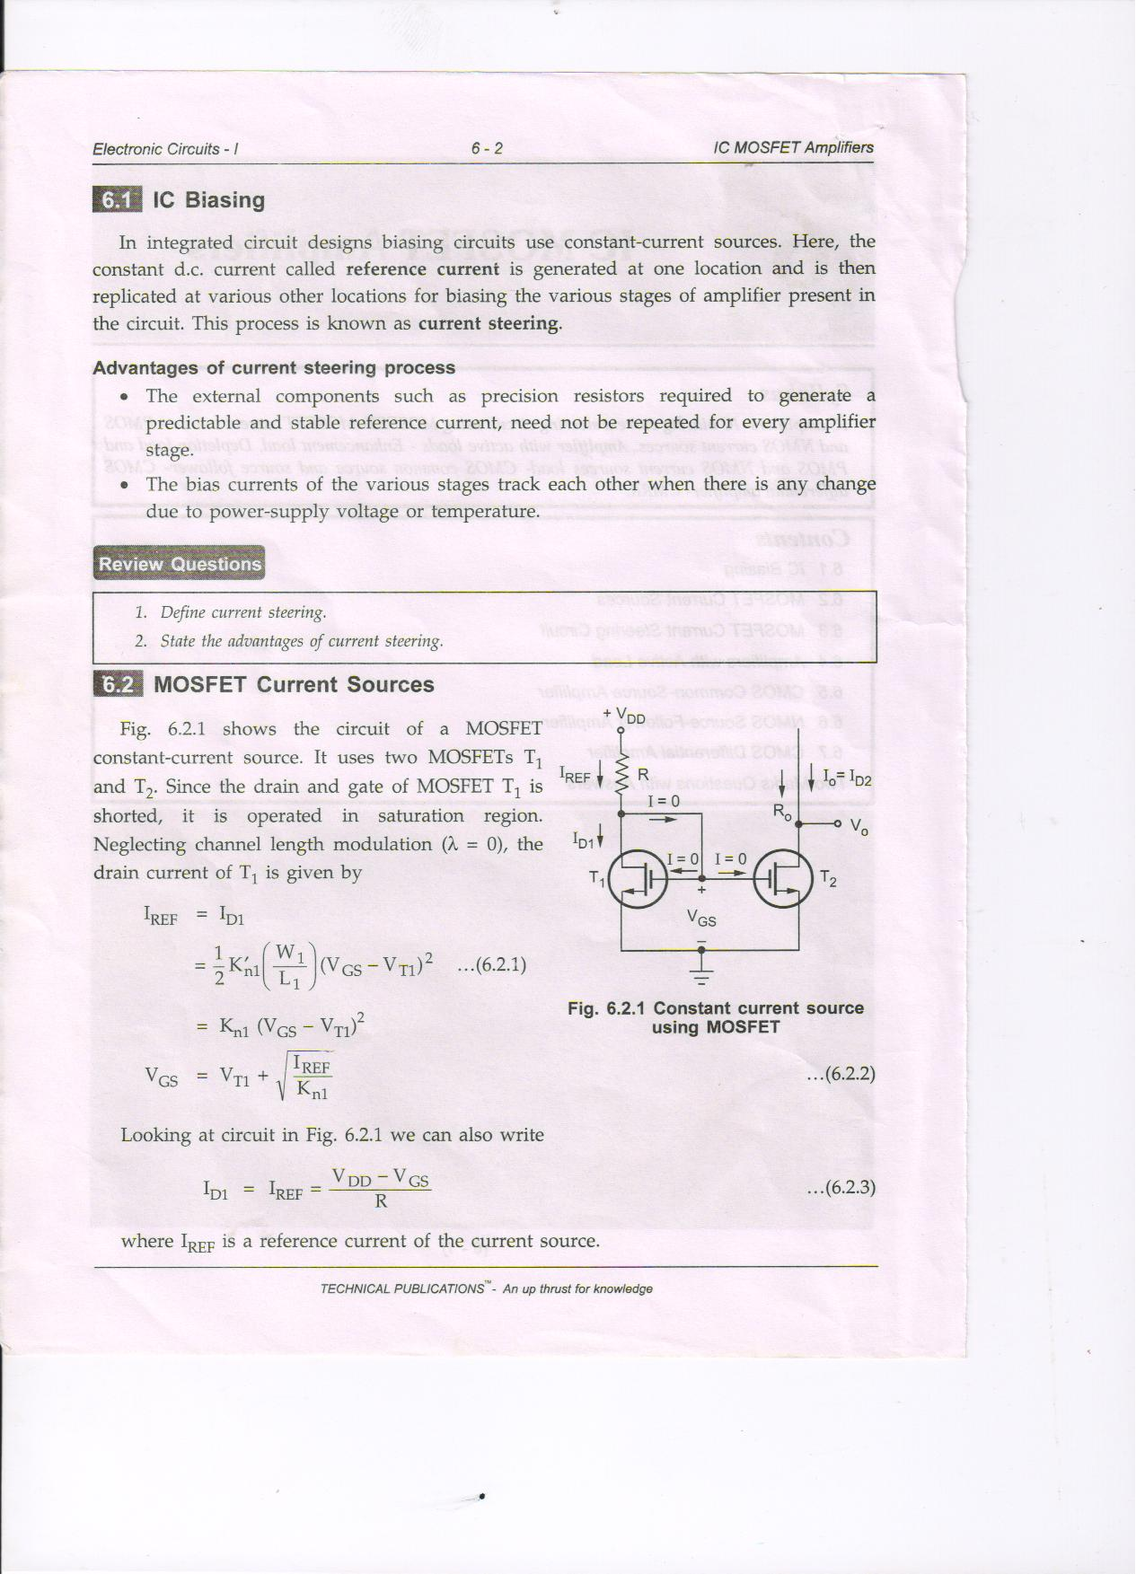

1. **Define override voltage**

In the MOSFET current sources out of two transistors , ensure that T2 is operated in saturation

V0 ≥ VGS - VT

or

V0 ≥ Vov

Where Vov is the override voltage.

1. **Draw MOSFET constant current source circuit with active load.**

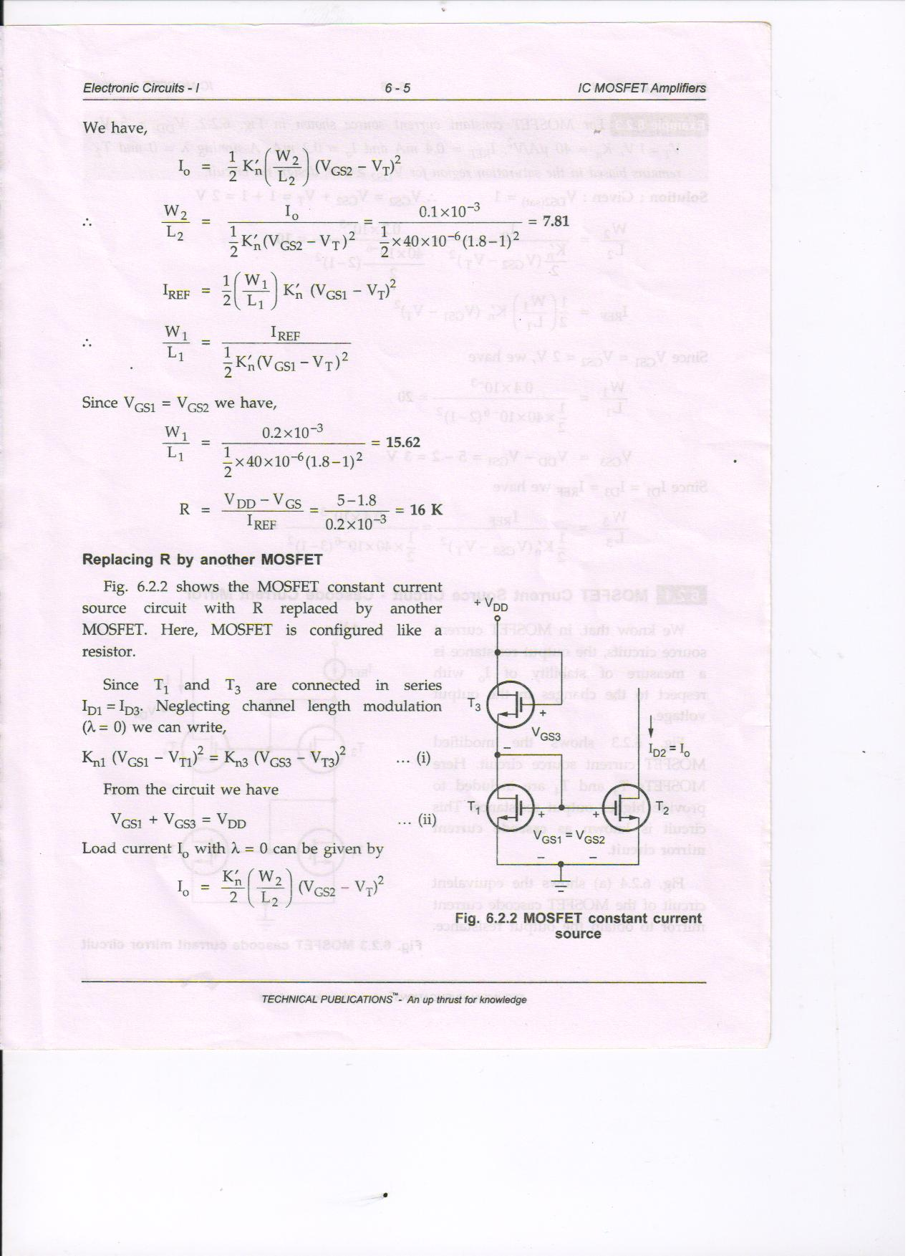

1. **Give the expression for output resistance of cascade current mirror circuit**

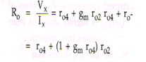

1. **State the advantages of Wilson current mirror circuit.**

The advantage of Wilson circuit is the **increase in output resistance** and hence to increase the **stability** of output current.

1. **Draw the MOSFET current steering circuit.**

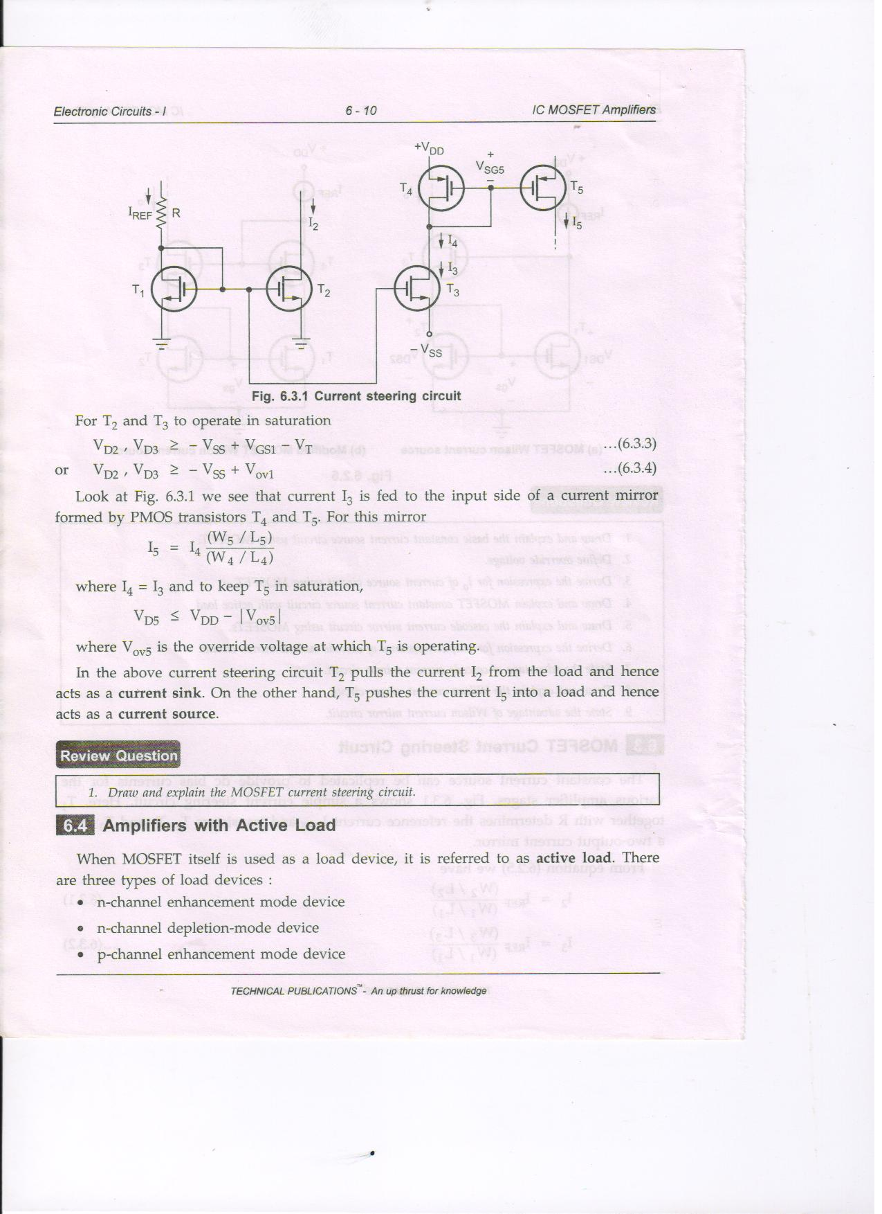

1. **List the various types of active load**

When MOSFET itself is used as a load device. It is called as active load. Three types of loads are

N- channel enhancement mode device

N- channel depletion mode device

P - channel enhancement mode device

1. **Draw the voltage transfer characteristics of NMOS amplifier with enhancement load**

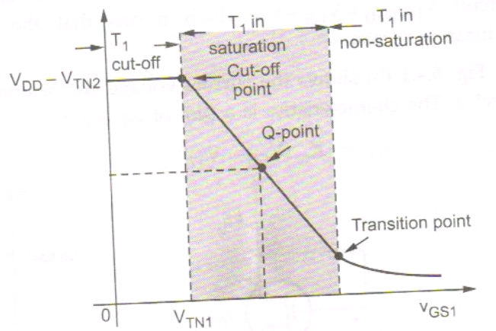

1. **Give the expression for small signal voltage gain of NMOS amplifier with depletion load.**

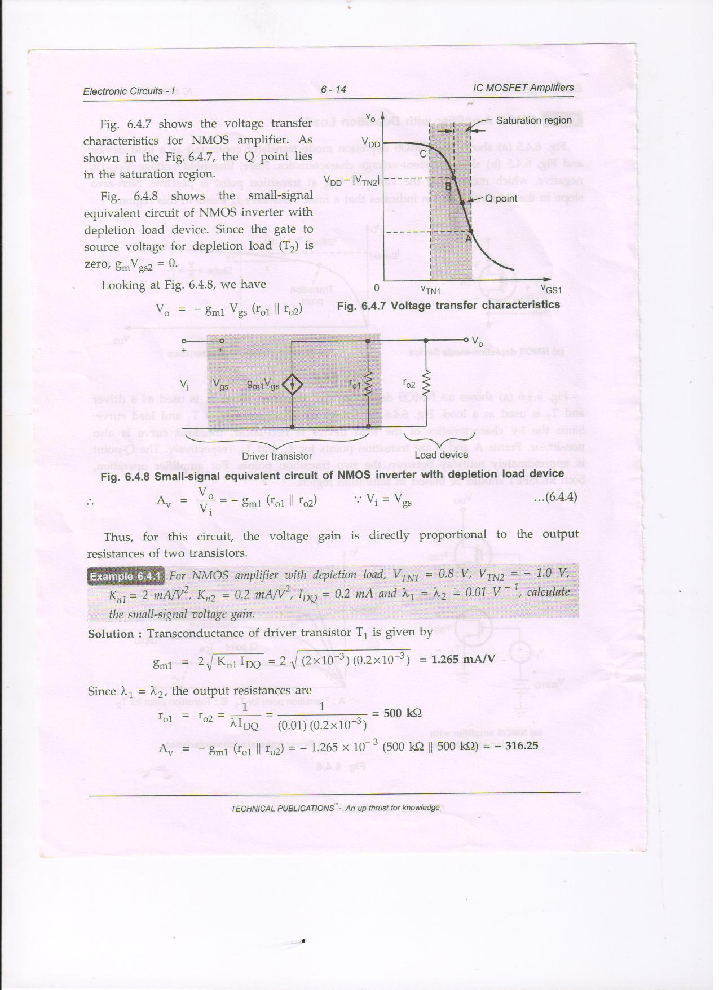

Voltage gain of is directly proportional to the output resistance of the two transistor.

1. **State the advantage of CMOS common source follower amplifier**
2. Like NMOS amplifier with depletion load , CMOS common source amplifier also provides large small-signal voltage gain
3. CMOS amplifier does not suffer from body effect.
4. **Draw the CMOS differential amplifier**

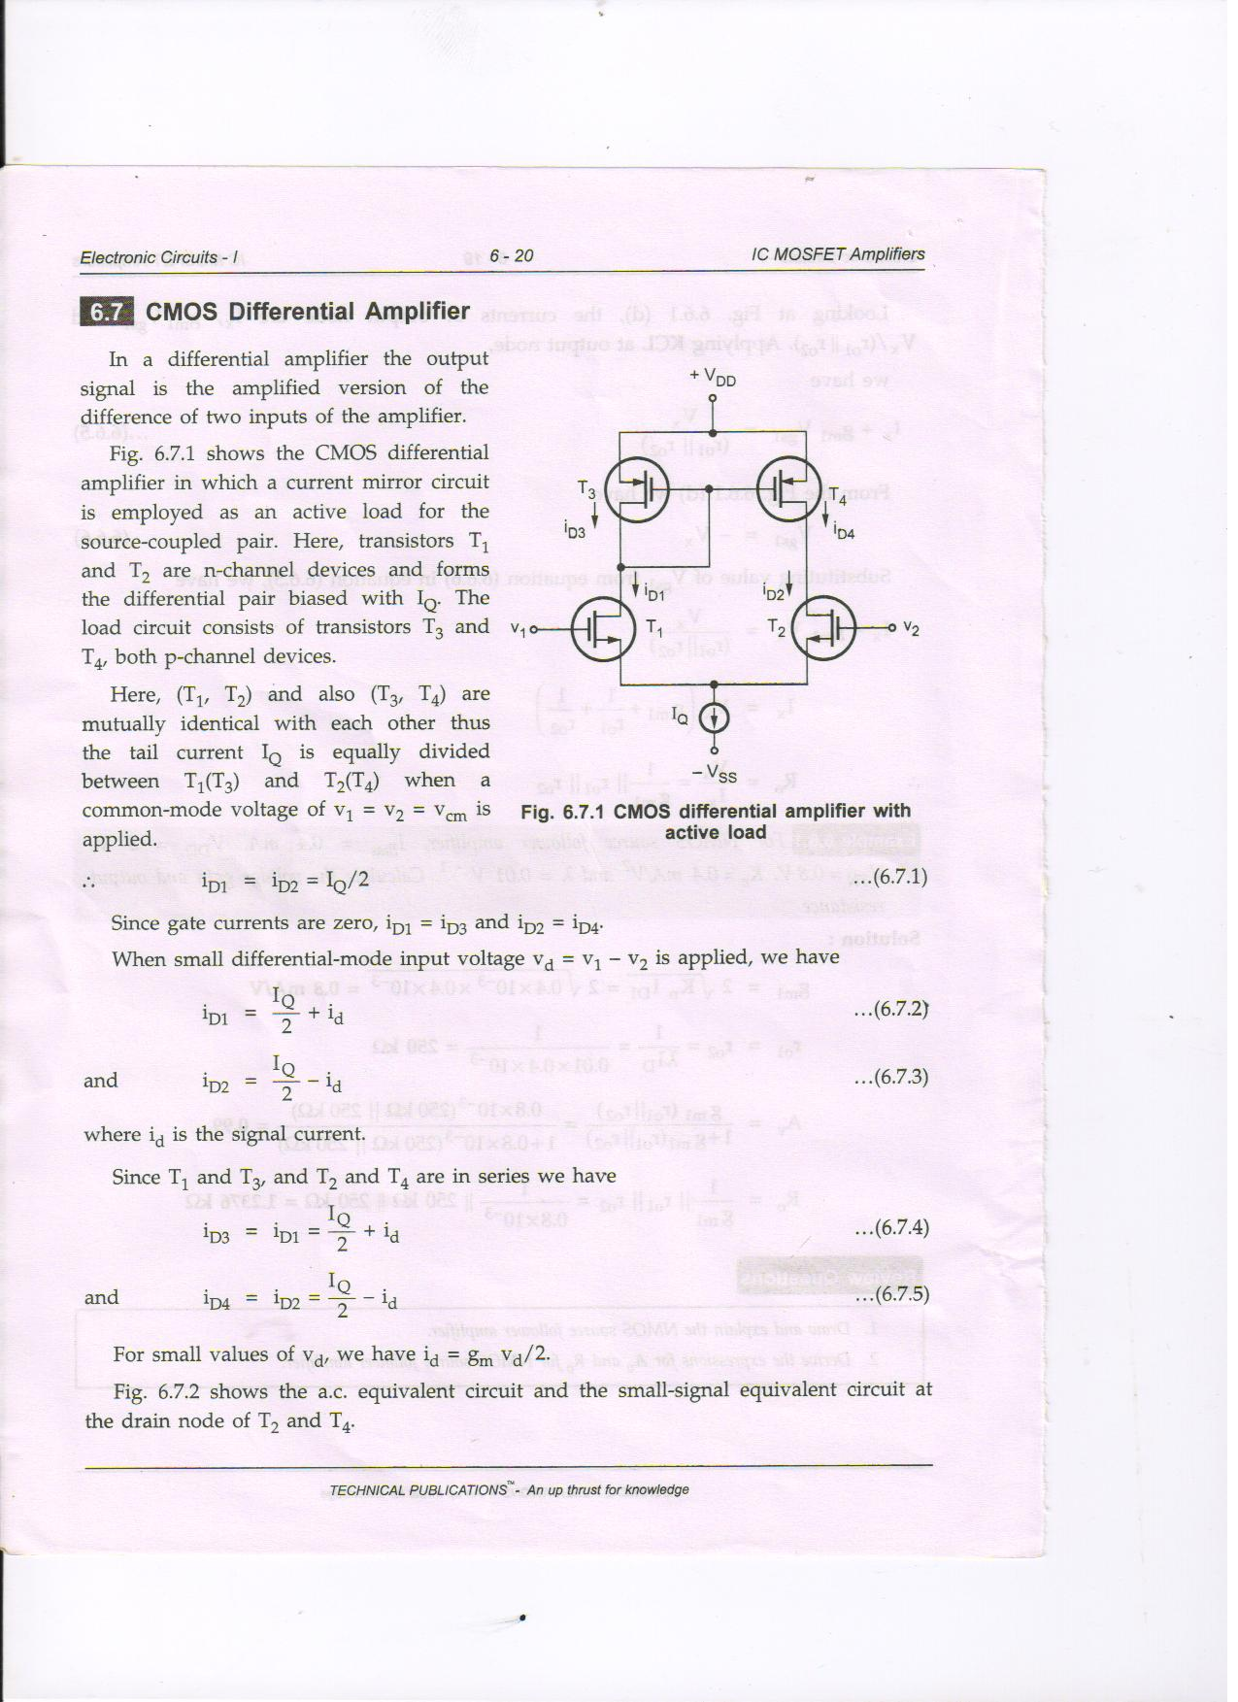

1. **Draw the NMOS source follower amplifier**

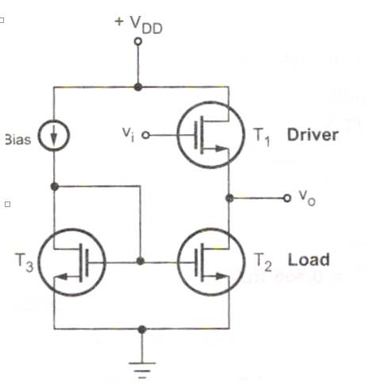

1. **Give the expression for Ad, Acm and CMRR for CMOS differential amplifier.**

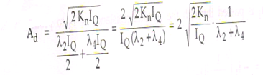

PART B

1. **Draw and explain the MOSFET current steering circuit.**

**T**he constant current source can be replaced to provide dc bias currents for the various amplifier stages.

T1 together with R determines the reference current

T1,T2 andT3  forms a two output current mirror

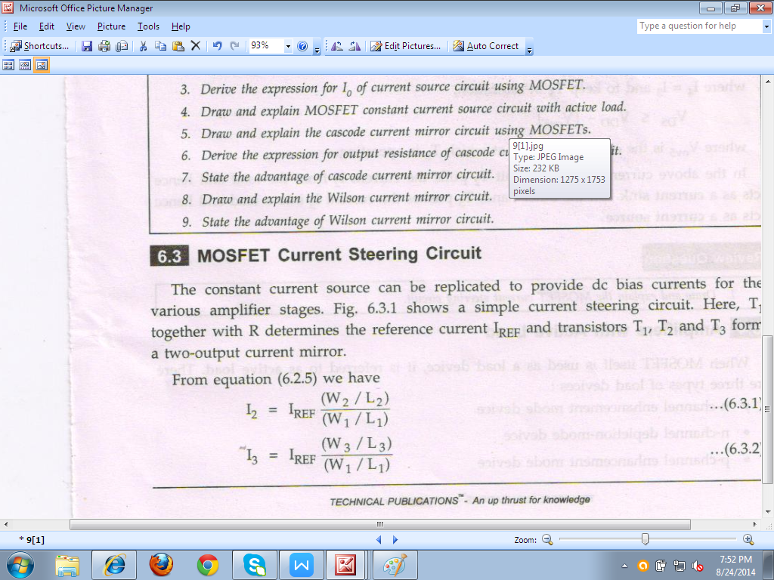



For T2 and T3 operate in a saturation region

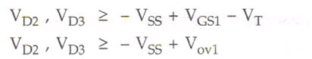

Current I3 is fed to the input of a current mirror formed by PMOS transistors T4 and T5 . For this mirror

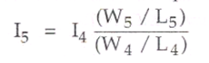

Where I4 = I3 to keep T5 in saturation



Where Vov5 is the over ride voltage at which T5 is operating.

In the above circuit T2 pulls the current I2 from the load and hence act as a **current sink.** On the other hand T5 pushes the current I5 into a load and hence acts as a **current source.**

1. **Draw and explain the CMOS common source amplifier with the help of various characteristics.**

* Fig shows a the CMOS common source amplifier
* N - channel enhancement mode MOSFET (T1) is used as a driver and p-channel enhancement mode MOSFET (T2) is used as a active load.

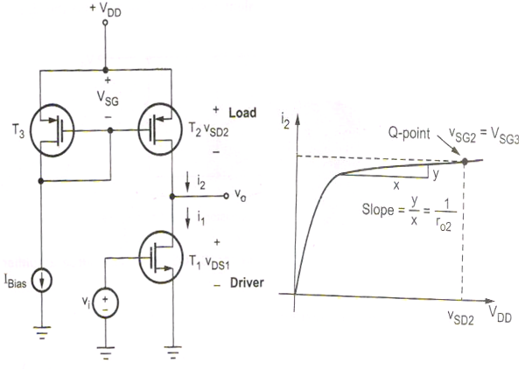

Fig : a Common source amplifier Fig : b PMOS active load I-V characteristics

* Fig b shows the PMOS active load I-V characteristics.
* T3 and Ibias is used to keep the source to gate voltage of T2 constant.

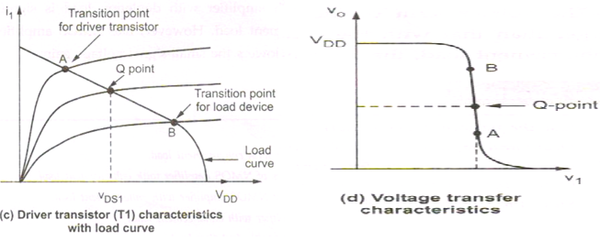

Fig c shows the driver characteristics with the load curve. Point A and B are transition points for T1 and T2 respectively.

Fig d shows the voltage transfer characteristics for common source amplifier.It also shows the transition points and Q-point.

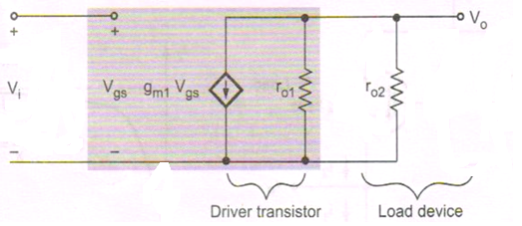

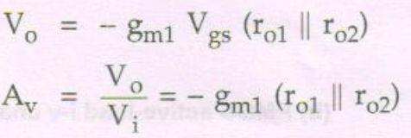

**Advantage of CMOS common source follower amplifier**

1. Like NMOS amplifier with depletion load , CMOS common source amplifier also provides large small-signal voltage gain

2. CMOS amplifier does not suffer from body effect.

1. **Sixteen mark Questions from the portions of class test – 8**
2. **Draw and explain the NMOS source follower amplifier and derive the expressions for Av and Ro.**

* Figure shows the NMOS source follower.
* T2 - Active load, T1 - driver in n-channel
* T3 and Ibias provides bias for the load device.

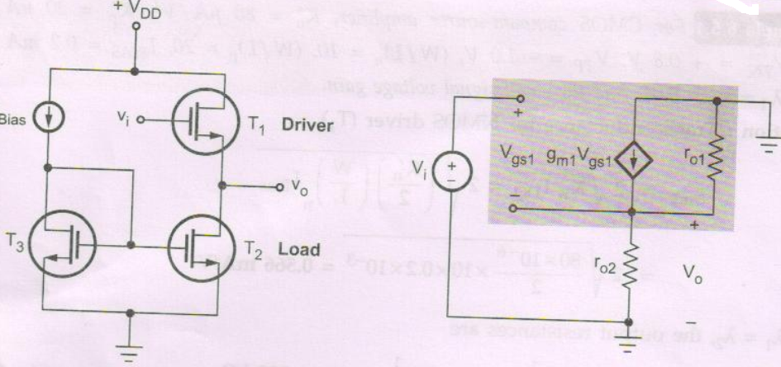

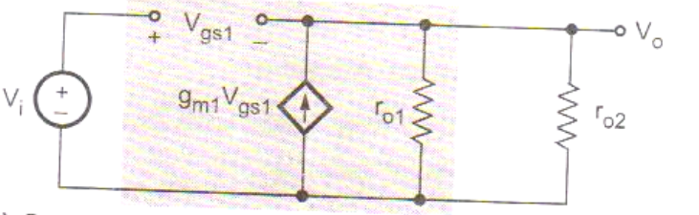

**Voltage Gain**



Applying KVL to the outer loop, we have

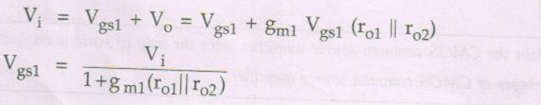

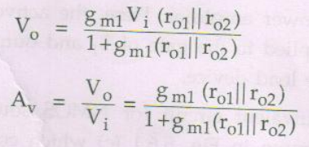

**Output resistance**

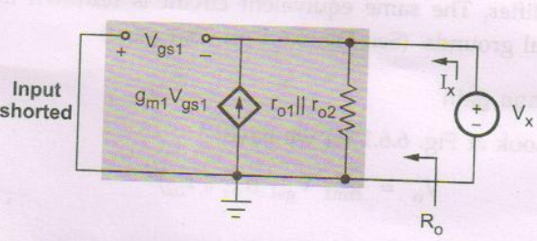

Figure shows the small signal equivalent circuit to determine output resistance.

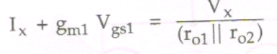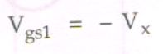

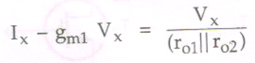

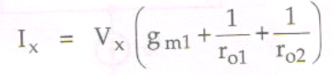

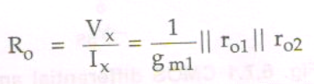

1. **Draw and explain the CMOS differential amplifier and derive the expressions for Ad , Acm and CMRR.**

* In a differential amplifier the output signal is the amplified version of the difference of two inputs of the amplifier.
* In which a current mirror circuit is employed as an active load for the source coupled pair**.**
* T1 and T2 - n channel device
* T3 and T4 - p channel device
* T1 , T2 and T3,T4 are mutually identical-with each other.
* Thus tail current is equally divided between T1(T3) and T2(T4) when a common voltage of V1 = V2 = Vcm is applied.

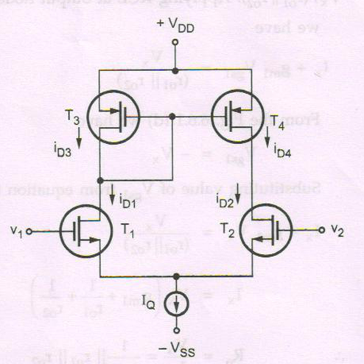



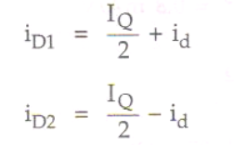

Since T1 and T3 and T2 and T4 are in series we have

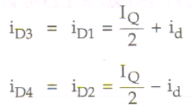

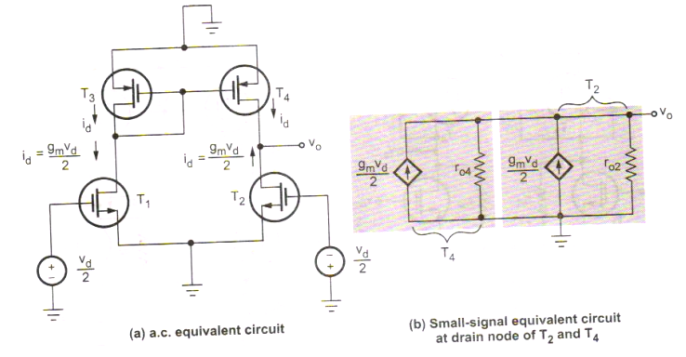

**Differential Gain (Ad)**

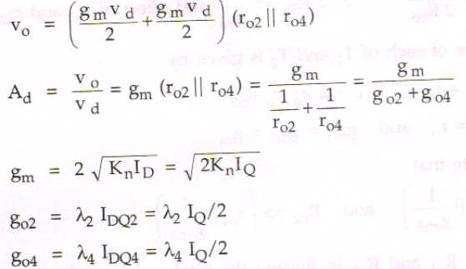

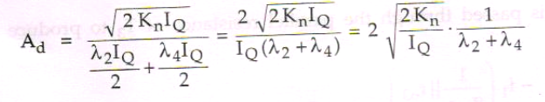

**Common mode gain**

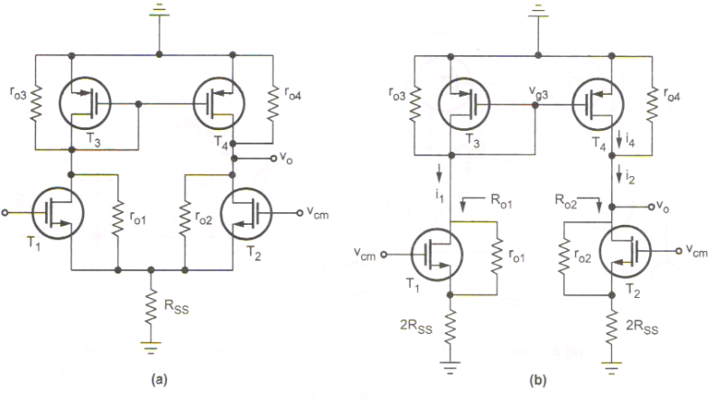



The output resistance of T1 and T2 is given by

